1. **INTRODUCTION**
   1. *overview*
      * *Description of the project*

Project Description:

**. Fresh Bites Catering, a catering service, utilizes Zoho Books to manage their sales, track inventory, and handle invoicing. They can generate professional invoices for clients and track expenses related to ingredients and supplies. Zoho Books helps them maintain accurate financial records and streamline their catering operations**.

* 1. **PURPOSE**

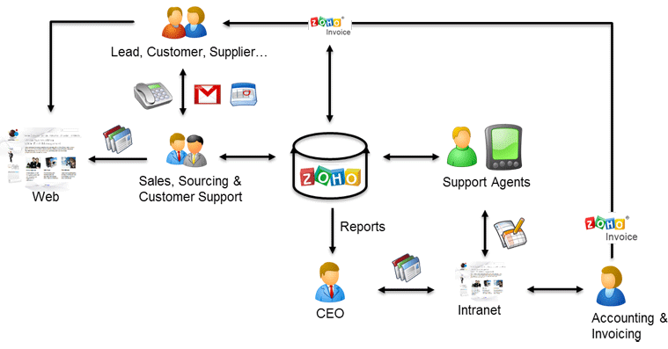

1. **Problem definition & design Thinking**
   1. *Empathy map*

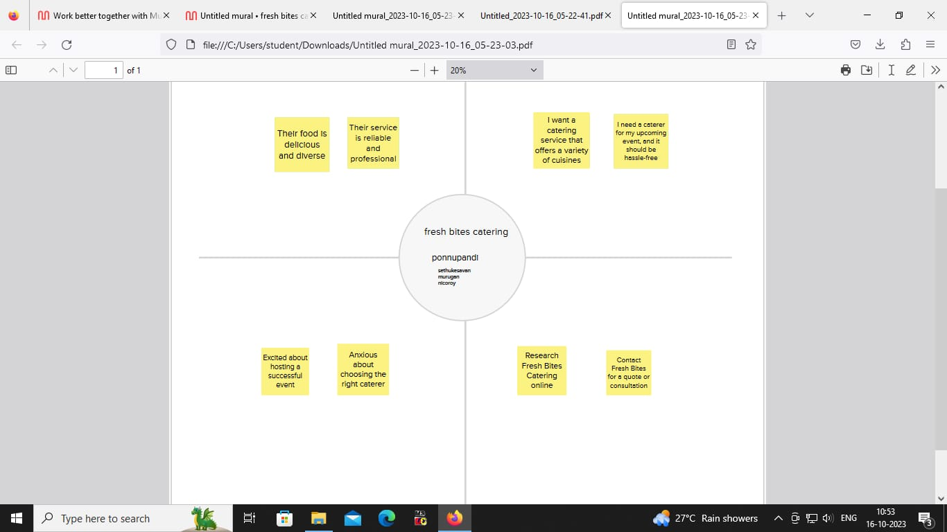

* 1. *Ideation & Brainstorming map*

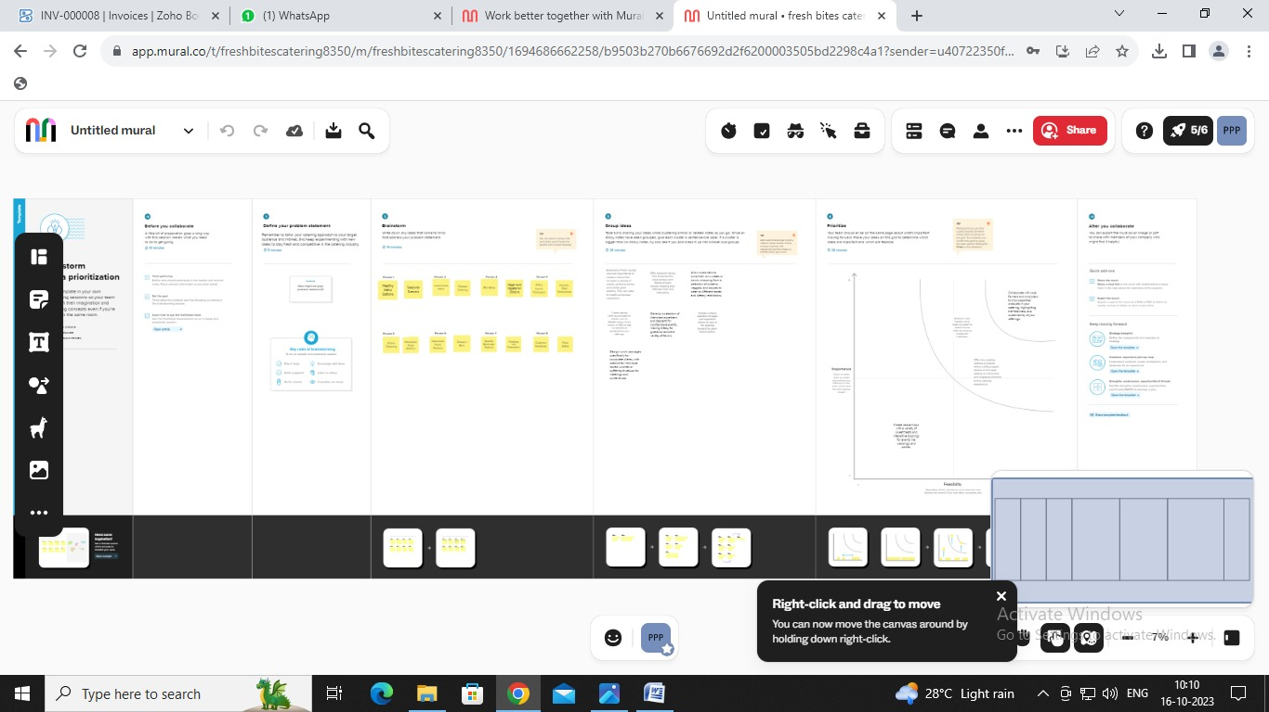

1. **Result Profit&loss**

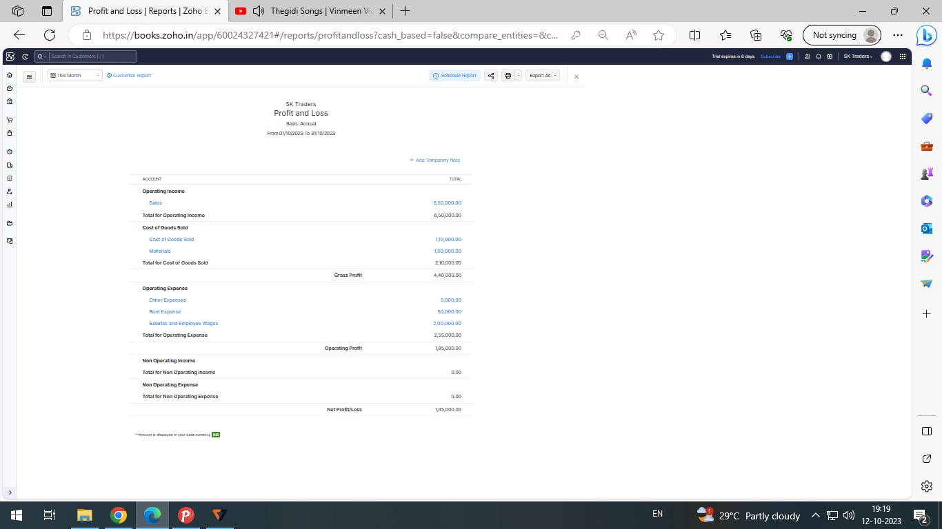

Balance sheet:

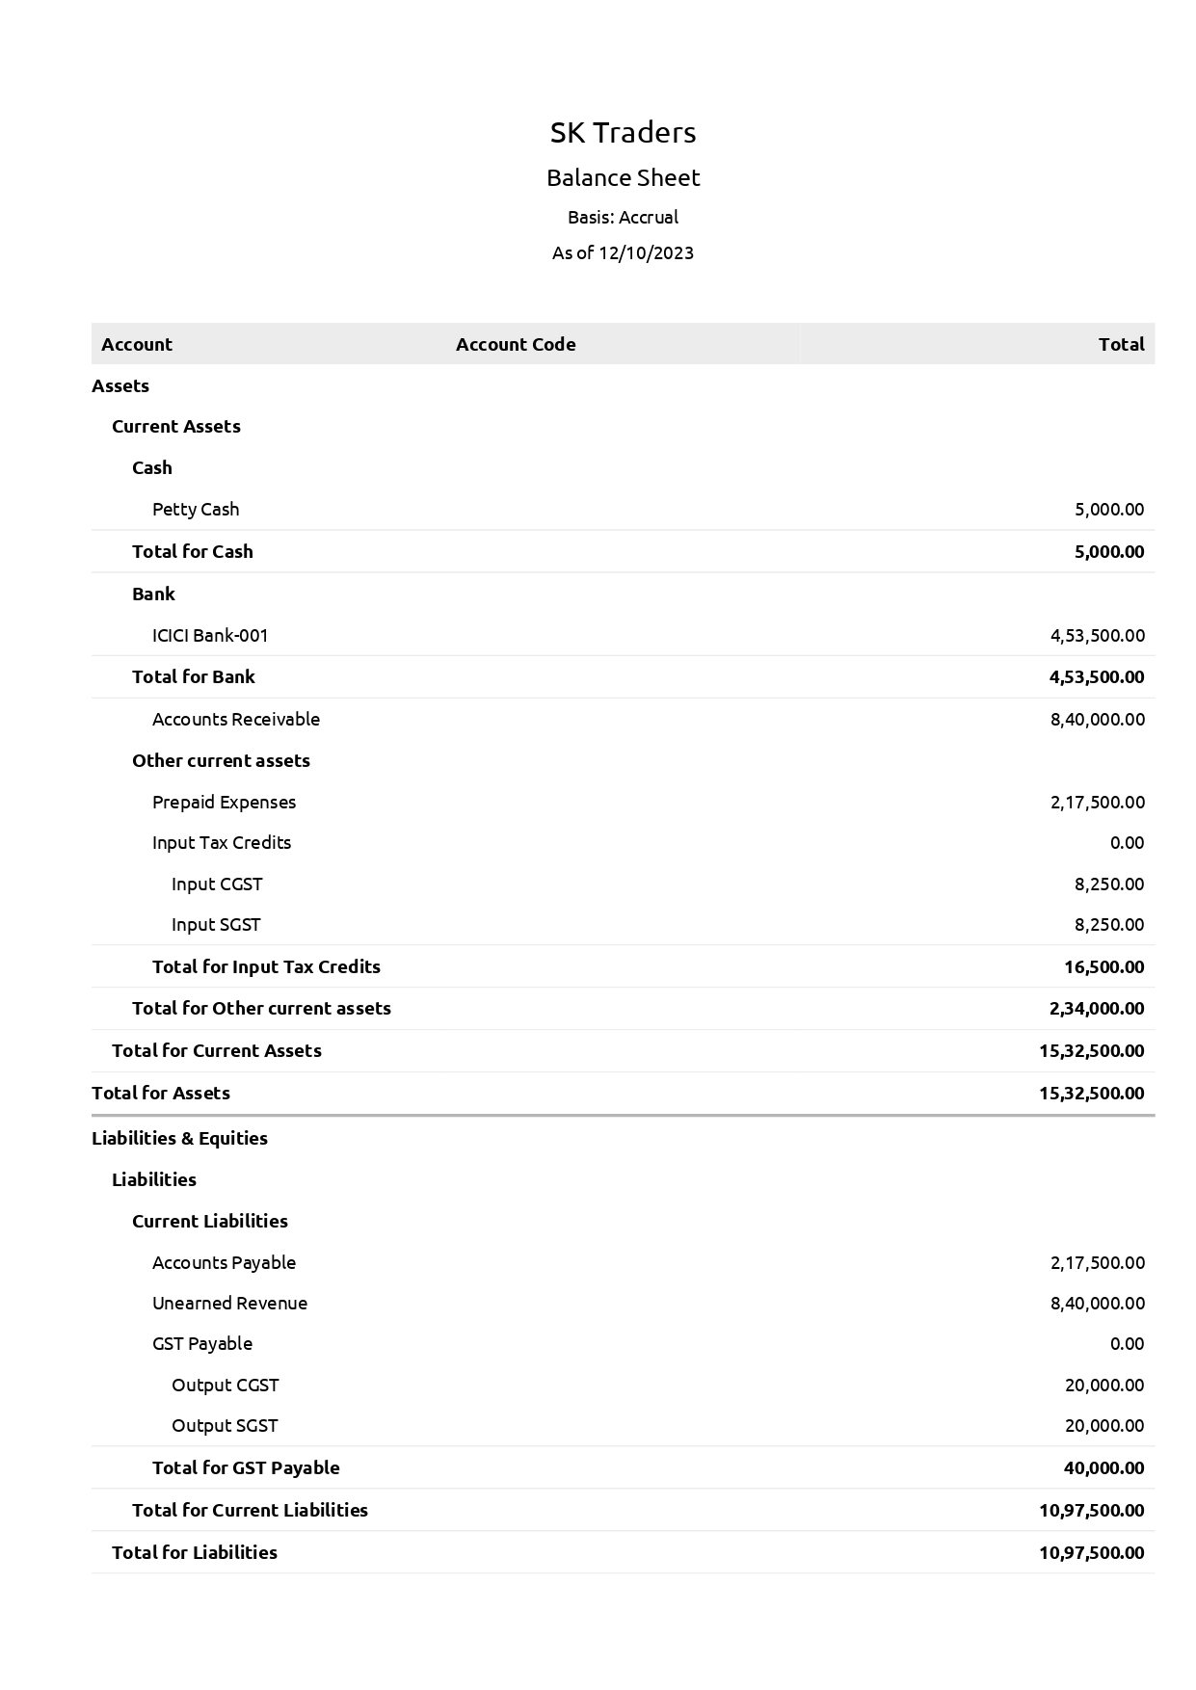

Purchase order:

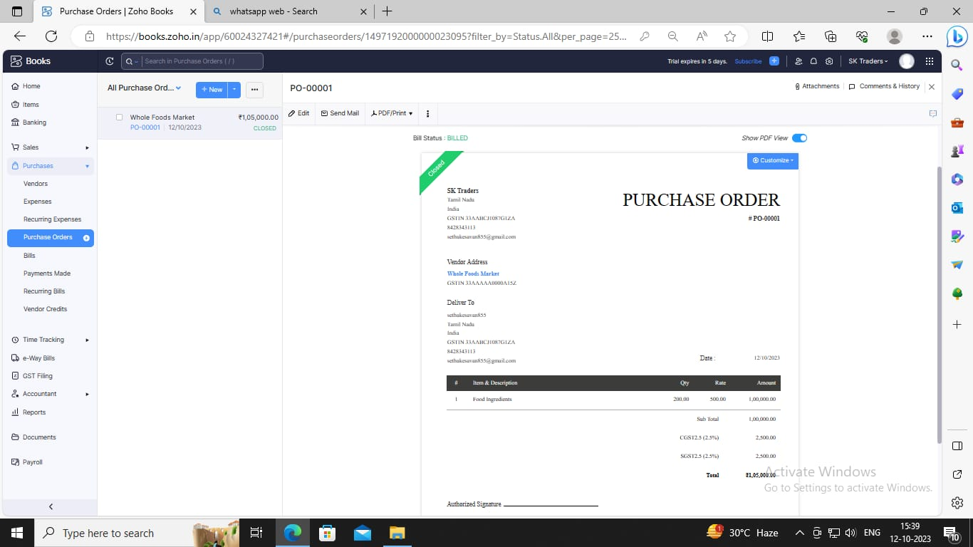

Sales order:

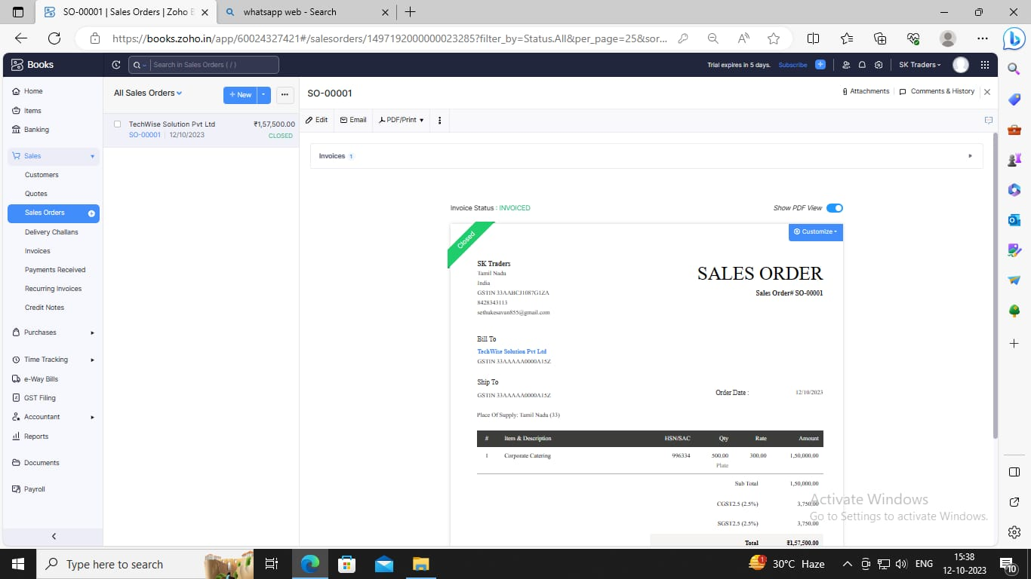

Bills :

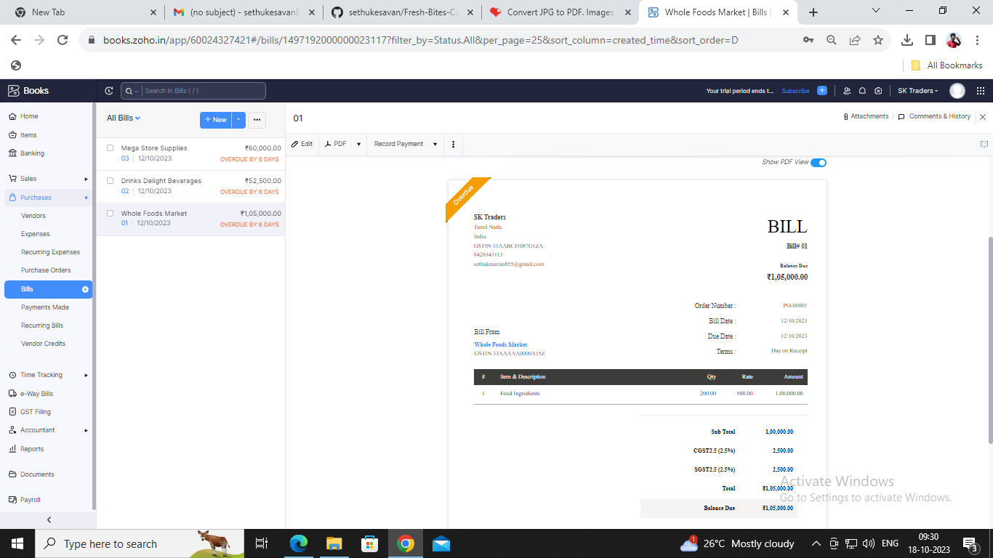

Invoice:

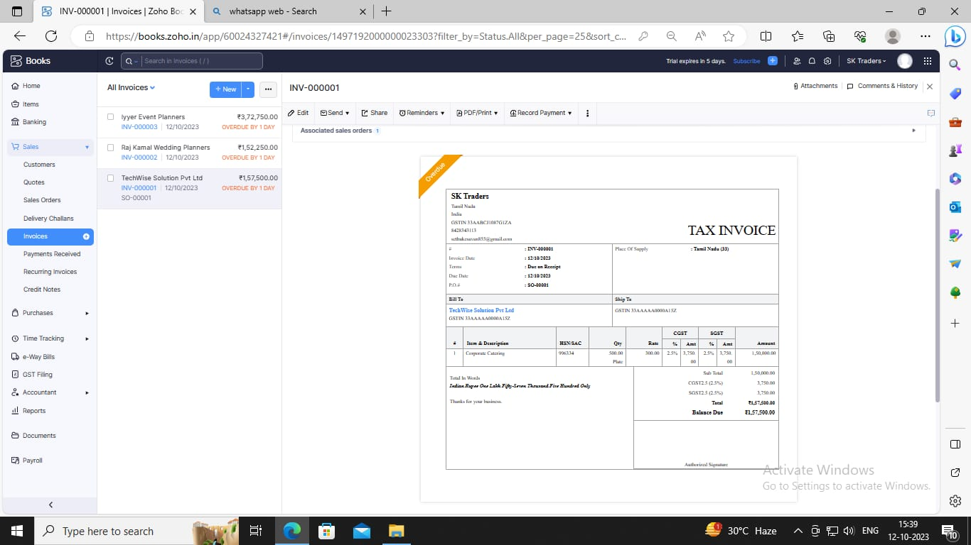

ADVANTAGES OF Fresh Bites Catering:

* Catering food will help you thrown an amazing party.
* Expense and tracking.

DISADVANTAGES OF Fresh Bites Catering :

It will bedifficult in the beginning of your career.

Difficult to modify bills.

1. *APPLICATIONS:*

This application used to maintain the company details and ledger accounts,profit&loss a/c and balance sheet of the company mega store supplies

1. **Conclusion:**

It is a service that DELIVERY,COOKS,and SERVES FOOD on sites at a clients location

1. **FUTURE SCOPE:**

Preparing and storing food safety before during events,setting up all tables and food services areas with chairs,lines and dishes,service food to guests at events.it also helped to reduce the work of the accountant to maintain.

1. **APPENDIX:**

<https://github.com/sethukesavan/Fresh-Bites-Catering-/tree/main>

|  |
| --- |
| <!DOCTYPE html> |
|  | <html lang="en" data-color-mode="auto" data-light-theme="light" data-dark-theme="dark" data-a11y-animated-images="system" data-a11y-link-underlines="false"> |
|  |  |
|  | <style> |
|  | /* for each iteration, uncomment the CSS variable */ |
|  |  |
|  | /* light themes */ |
|  | [data-color-mode="light"][data-light-theme*="light"], |
|  | [data-color-mode="auto"][data-light-theme*="light"] { |
|  | /* iteration 1 */ |
|  | --border-color-iteration-1: #C8CCD0; |
|  | /* iteration 2 */ |
|  | --border-color-iteration-2: #BABFC5; |
|  | /* iteration 3 */ |
|  | --border-color-iteration-3: #A6ADB4; |
|  | /* iteration final */ |
|  | --border-color-iteration-4: #868F99; |
|  |  |
|  | /* the first value is the final step, which falls back to previous iterations */ |
|  | --control-borderColor-rest: var(--border-color-iteration-4, var(--border-color-iteration-3, var(--border-color-iteration-2, var(--border-color-iteration-1)))) !important; |
|  | } |
|  |  |
|  | /* dark themes */ |
|  | [data-color-mode="dark"][data-dark-theme*="dark"], |
|  | [data-color-mode="auto"][data-light-theme*="dark"] { |
|  | /* iteration 1 */ |
|  | --border-color-iteration-1: #363940; |
|  | /* iteration 2 */ |
|  | --border-color-iteration-2: #3F434B; |
|  | /* iteration 3 */ |
|  | --border-color-iteration-3: #4B5159; |
|  | /* iteration final */ |
|  | --border-color-iteration-4: #666E79; |
|  |  |
|  | /* the first value is the final step, which falls back to previous iterations */ |
|  | --control-borderColor-rest: var(--border-color-iteration-4, var(--border-color-iteration-3, var(--border-color-iteration-2, var(--border-color-iteration-1)))) !important; |
|  | } |
|  |  |
|  | [data-color-mode="dark"][data-dark-theme="dark_dimmed"], |
|  | [data-color-mode="dark"][data-dark-theme="light_high_contrast"], |
|  | [data-color-mode="dark"][data-dark-theme="dark_high_contrast"], |
|  | [data-color-mode="light"][data-light-theme="dark_dimmed"], |
|  | [data-color-mode="light"][data-light-theme="light_high_contrast"], |
|  | [data-color-mode="light"][data-light-theme="dark_high_contrast"] { |
|  | /* skip these themes, use the fallback */ |
|  | --control-borderColor-rest: initial !important; |
|  | } |
|  |  |
|  | @media (prefers-color-scheme: dark) { |
|  | /* dark colors in dark mode */ |
|  | [data-color-mode="auto"][data-dark-theme*="dark"] { |
|  | /* iteration 1 */ |
|  | --border-color-iteration-1: #363940; |
|  | /* iteration 2 */ |
|  | --border-color-iteration-2: #3F434B; |
|  | /* iteration 3 */ |
|  | --border-color-iteration-3: #4B5159; |
|  | /* iteration final */ |
|  | --border-color-iteration-4: #666E79; |
|  |  |
|  | /* the first value is the final step, which falls back to previous iterations */ |
|  | --control-borderColor-rest: var(--border-color-iteration-4, var(--border-color-iteration-3, var(--border-color-iteration-2, var(--border-color-iteration-1)))) !important; |
|  | } |
|  |  |
|  | /* light colors in dark mode */ |
|  | [data-color-mode="auto"][data-dark-theme*="light"] { |
|  | /* iteration 1 */ |
|  | --border-color-iteration-1: #C8CCD0; |
|  | /* iteration 2 */ |
|  | --border-color-iteration-2: #BABFC5; |
|  | /* iteration 3 */ |
|  | --border-color-iteration-3: #A6ADB4; |
|  | /* iteration final */ |
|  | --border-color-iteration-4: #868F99; |
|  |  |
|  | /* the first value is the final step, which falls back to previous iterations */ |
|  | --control-borderColor-rest: var(--border-color-iteration-4, var(--border-color-iteration-3, var(--border-color-iteration-2, var(--border-color-iteration-1)))) !important; |
|  | } |
|  |  |
|  | [data-color-mode="auto"][data-dark-theme="dark_dimmed"], |
|  | [data-color-mode="auto"][data-dark-theme="light_high_contrast"], |
|  | [data-color-mode="auto"][data-dark-theme="dark_high_contrast"] { |
|  | /* skip these themes, use the fallback */ |
|  | --control-borderColor-rest: initial !important; |
|  | } |
|  | } |
|  |  |
|  | @media (prefers-color-scheme: light) { |
|  | /* dark colors in light mode */ |
|  | [data-color-mode="auto"][data-light-theme*="dark"] { |
|  | /* iteration 1 */ |
|  | --border-color-iteration-1: #363940; |
|  | /* iteration 2 */ |
|  | --border-color-iteration-2: #3F434B; |
|  | /* iteration 3 */ |
|  | --border-color-iteration-3: #4B5159; |
|  | /* iteration final */ |
|  | --border-color-iteration-4: #666E79; |
|  |  |
|  | /* the first value is the final step, which falls back to previous iterations */ |
|  | --control-borderColor-rest: var(--border-color-iteration-4, var(--border-color-iteration-3, var(--border-color-iteration-2, var(--border-color-iteration-1)))) !important; |
|  | } |
|  |  |
|  | /* light colors in light mode */ |
|  | [data-color-mode="auto"][data-light-theme*="light"] { |
|  | /* iteration 1 */ |
|  | --border-color-iteration-1: #C8CCD0; |
|  | /* iteration 2 */ |
|  | --border-color-iteration-2: #BABFC5; |
|  | /* iteration 3 */ |
|  | --border-color-iteration-3: #A6ADB4; |
|  | /* iteration final */ |
|  | --border-color-iteration-4: #868F99; |
|  |  |
|  | /* the first value is the final step, which falls back to previous iterations */ |
|  | --control-borderColor-rest: var(--border-color-iteration-4, var(--border-color-iteration-3, var(--border-color-iteration-2, var(--border-color-iteration-1)))) !important; |
|  | } |
|  |  |
|  | [data-color-mode="auto"][data-light-theme="dark_dimmed"], |
|  | [data-color-mode="auto"][data-light-theme="light_high_contrast"], |
|  | [data-color-mode="auto"][data-light-theme="dark_high_contrast"] { |
|  | /* skip these themes, use the fallback */ |
|  | --control-borderColor-rest: initial !important; |
|  | } |
|  | } |

rel=”stylesheet”

data-href=https://github.githubassets.com/assets/dark_high_contrast-8438e75afd36.css><lin k data-color-theme=”dark_colorblind” crossorigin=”anonymous” media=”all” rel=”stylesheet” data-href=https://github.githubassets.com/assets/dark_colorblind-bf5665b96628.css><link data-color-theme=”light_colorblind” crossorigin=”anonymous” media=”all” rel=”stylesheet” data-href=https://github.githubassets.com/assets/light_colorblind-c414b5ba1dce.css><link data-color-theme=”light_high_contrast” crossorigin=”anonymous” media=”all” rel=”stylesheet”

data-href=https://github.githubassets.com/assets/light_high_contrast-e5868b7374db.css><lin k data-color-theme=”light_tritanopia” crossorigin=”anonymous” media=”all” rel=”stylesheet” data-href=https://github.githubassets.com/assets/light_tritanopia-299ac9c64ec0.css><link data-color-theme=”dark_tritanopia” crossorigin=”anonymous” media=”all” rel=”stylesheet” data-href=h[ttps://github.githubassets.com/assets/dark_tritanopia-3a26e78ad0ff.css>](https://github.githubassets.com/assets/light_high_contrast-e5868b7374db.css)

<link cros[sorigin=”anonymous” media=”all” rel=”stylesheet”](https://github.githubassets.com/assets/dark_tritanopia-3a26e78ad0ff.css) href=”./NM2023TMID22539_profit_and_loss.pdf at main · asmku643mku643c1c31260_NM2023TMID22539 · GitHub_files/primer-primitives-6143c8f97ed1.css”>

<link crossorigin=”anonymous” media=”all” rel=”stylesheet” href=”./NM2023TMID22539_profit_and_loss.pdf at main · asmku643mku643c1c31260_NM2023TMID22539 · GitHub_files/primer-d6dcdf72e61d.css”>

<link crossorigin=”anonymous” media=”all” rel=”stylesheet” href=”./NM2023TMID22539_profit_and_loss.pdf at main · asmku643mku643c1c31260_NM2023TMID22539 · GitHub_files/global-ab1c3e3e5644.css”>

<link crossorigin=”anonymous” media=”all” rel=”stylesheet” href=”./NM2023TMID22539_profit_and_loss.pdf at main · asmku643mku643c1c31260_NM2023TMID22539 · GitHub_files/github-757ef6ea9a38.css”>

<link crossorigin=”anonymous” media=”all” rel=”stylesheet” href=”./NM2023TMID22539_profit_and_loss.pdf at main · asmku643mku643c1c31260_NM2023TMID22539 · GitHub_files/code-71ecd5638fbf.css”>

<script type=”application/json”

id=”client-env”>{“locale”:”en”,”featureFlags”:[“failbot_handle_non_errors”,”geojson_azure_m aps”,”image_metric_tracking”,”turbo_experiment_risky”,”sample_network_conn_type”]}</scri pt>

<script crossorigin=”anonymous” defer=”defer” type=”application/javascript” src=”./NM2023TMID22539_profit_and_loss.pdf at main · asmku643mku643c1c31260_NM2023TMID22539 ·

GitHub_files/wp-runtime-86f14561f3b0.js.download”></script>

<script crossorigin=”anonymous” defer=”defer” type=”application/javascript” src=”./NM2023TMID22539_profit_and_loss.pdf at main · asmku643mku643c1c31260_NM2023TMID22539 ·

GitHub_files/vendors-node_modules_dompurify_dist_purify_js-64d590970fa6.js.download”>

</script>

<script crossorigin=”anonymous” defer=”defer” type=”application/javascript” src=”./NM2023TMID22539_profit_and_loss.pdf at main · asmku643mku643c1c31260_NM2023TMID22539 ·

GitHub_files/vendors-node_modules_stacktrace-parser_dist_stack-trace-parser_esm_js-node_ modules_github_bro-a4c183-18bf85b8e9f4.js.download”></script>

<script crossorigin=”anonymous” defer=”defer” type=”application/javascript” src=”./NM2023TMID22539_profit_and_loss.pdf at main · asmku643mku643c1c31260_NM2023TMID22539 ·

GitHub_files/ui_packages_soft-nav_soft-nav_ts-56133143b228.js.download”></script>

<script crossorigin=”anonymous” defer=”defer” type=”application/javascript” src=”./NM2023TMID22539_profit_and_loss.pdf at main · asmku643mku643c1c31260_NM2023TMID22539 ·

GitHub_files/environment-fc6543d75794.js.download”></script>

<script crossorigin=”anonymous” defer=”defer” type=”application/javascript” src=”./NM2023TMID22539_profit_and_loss.pdf at main · asmku643mku643c1c31260_NM2023TMID22539 ·

GitHub_files/vendors-node_modules_github_selector-observer_dist_index_esm_js-2646a2c53 3e3.js.download”></script>

<script crossorigin=”anonymous” defer=”defer” type=”application/javascript” src=”./NM2023TMID22539_profit_and_loss.pdf at main · asmku643mku643c1c31260_NM2023TMID22539 ·

GitHub_files/vendors-node_modules_primer_behaviors_dist_esm_focus-zone_js-d55308df50 23.js.download”></script>

<script crossorigin=”anonymous” defer=”defer” type=”application/javascript” src=”./NM2023TMID22539_profit_and_loss.pdf at main · asmku643mku643c1c31260_NM2023TMID22539 ·

GitHub_files/vendors-node_modules_github_relative-time-element_dist_index_js-99e288659 d4f.js.download”></script>

<script crossorigin=”anonymous” defer=”defer” type=”application/javascript” src=”./NM2023TMID22539_profit_and_loss.pdf at main · asmku643mku643c1c31260_NM2023TMID22539 ·

GitHub_files/vendors-node_modules_fzy_js_index_js-node_modules_github_combobox-nav_ dist_index_js-node_modu-344bff-91b70bb50d68.js.download”></script>

<script crossorigin=”anonymous” defer=”defer” type=”application/javascript” src=”./NM2023TMID22539_profit_and_loss.pdf at main · asmku643mku643c1c31260_NM2023TMID22539 ·

GitHub_files/vendors-node_modules_delegated-events_dist_index_js-node_modules_github_ auto-complete-element-81d69b-f766607dc0c8.js.download”></script>

<script crossorigin=”anonymous” defer=”defer” type=”application/javascript” src=”./NM2023TMID22539_profit_and_loss.pdf at main · asmku643mku643c1c31260_NM2023TMID22539 ·

GitHub_files/vendors-node_modules_github_filter-input-element_dist_index_js-node_module s_github_remote-inp-2e8678-d593bf262480.js.download”></script>

<script crossorigin=”anonymous” defer=”defer” type=”application/javascript” src=”./NM2023TMID22539_profit_and_loss.pdf at main · asmku643mku643c1c31260_NM2023TMID22539 ·

GitHub_files/vendors-node_modules_github_file-attachment-element_dist_index_js-node_m odules_primer_view-co-70ad06-9f8bb7e4a8fa.js.download”></script>

<script crossorigin=”anonymous” defer=”defer” type=”application/javascript” src=”./NM2023TMID22539_profit_and_loss.pdf at main · asmku643mku643c1c31260_NM2023TMID22539 ·

GitHub_files/github-elements-30961cfd137b.js.download”></script>

<script crossorigin=”anonymous” defer=”defer” type=”application/javascript” src=”./NM2023TMID22539_profit_and_loss.pdf at main · asmku643mku643c1c31260_NM2023TMID22539 ·

GitHub_files/element-registry-e5f51987a7c5.js.download”></script>

<script crossorigin=”anonymous” defer=”defer” type=”application/javascript” src=”./NM2023TMID22539_profit_and_loss.pdf at main · asmku643mku643c1c31260_NM2023TMID22539 ·

GitHub_files/vendors-node_modules_lit-html_lit-html_js-4ccebb6ebf7d.js.download”></script

>

<script crossorigin=”anonymous” defer=”defer” type=”application/javascript” src=”./NM2023TMID22539_profit_and_loss.pdf at main · asmku643mku643c1c31260_NM2023TMID22539 ·

GitHub_files/vendors-node_modules_github_mini-throttle_dist_index_js-node_modules_gith ub_alive-client_dist-bf5aa2-504c8d53fb8e.js.download”></script>

<script crossorigin=”anonymous” defer=”defer” type=”application/javascript” src=”./NM2023TMID22539_profit_and_loss.pdf at main · asmku643mku643c1c31260_NM2023TMID22539 ·

GitHub_files/vendors-node_modules_morphdom_dist_morphdom-esm_js-b1fdd7158cf0.js.do wnload”></script>

<script crossorigin=”anonymous” defer=”defer” type=”application/javascript” src=”./NM2023TMID22539_profit_and_loss.pdf at main · asmku643mku643c1c31260_NM2023TMID22539 ·

GitHub_files/vendors-node_modules_github_turbo_dist_turbo_es2017-esm_js-9a3541181451

.js.download”></script>

<script crossorigin=”anonymous” defer=”defer” type=”application/javascript” src=”./NM2023TMID22539_profit_and_loss.pdf at main · asmku643mku643c1c31260_NM2023TMID22539 ·

GitHub_files/vendors-node_modules_github_remote-form_dist_index_js-node_modules_scrol l-anchoring_dist_scro-52dc4b-e1e33bfc0b7e.js.download”></script>

<script crossorigin=”anonymous” defer=”defer” type=”application/javascript” src=”./NM2023TMID22539_profit_and_loss.pdf at main · asmku643mku643c1c31260_NM2023TMID22539 ·

GitHub_files/vendors-node_modules_color-convert_index_js-35b3ae68c408.js.download”></s cript>

<script crossorigin=”anonymous” defer=”defer” type=”application/javascript” src=”./NM2023TMID22539_profit_and_loss.pdf at main · asmku643mku643c1c31260_NM2023TMID22539 ·

GitHub_files/vendors-node_modules_primer_behaviors_dist_esm_dimensions_js-node_modu les_github_jtml_lib_index_js-a18147cea3a6.js.download”></script>

<script crossorigin=”anonymous” defer=”defer” type=”application/javascript” src=”./NM2023TMID22539_profit_and_loss.pdf at main ·

asmku643mku643c1c31260_NM2023TMID22539 ·

GitHub_files/vendors-node_modules_github_paste-markdown_dist_index_esm_js-node_mod ules_github_quote-select-581a1f-4a3074d34892.js.download”></script>

<script crossorigin=”anonymous” defer=”defer” type=”application/javascript” src=”./NM2023TMID22539_profit_and_loss.pdf at main · asmku643mku643c1c31260_NM2023TMID22539 · GitHub_files/app_assets_modules_github_details-dialog_ts-app_assets_modules_github_fetc h_ts-add1ab03ecb3.js.download”></script>

<script crossorigin=”anonymous” defer=”defer” type=”application/javascript” src=”./NM2023TMID22539_profit_and_loss.pdf at main · asmku643mku643c1c31260_NM2023TMID22539 · GitHub_files/app_assets_modules_github_updatable-content_ts-ui_packages_hydro-analytics

_hydro-analytics_ts-0a5a30c9b976.js.download”></script>

<script crossorigin=”anonymous” defer=”defer” type=”application/javascript” src=”./NM2023TMID22539_profit_and_loss.pdf at main · asmku643mku643c1c31260_NM2023TMID22539 · GitHub_files/app_assets_modules_github_onfocus_ts-app_assets_modules_github_sticky-scr oll-into-view_ts-c56a5dfc8975.js.download”></script>

<script crossorigin=”anonymous” defer=”defer” type=”application/javascript” src=”./NM2023TMID22539_profit_and_loss.pdf at main · asmku643mku643c1c31260_NM2023TMID22539 · GitHub_files/app_assets_modules_github_behaviors_task-list_ts-app_assets_modules_github

_sso_ts-ui_packages-7d50ad-9491f2be61ee.js.download”></script>

<script crossorigin=”anonymous” defer=”defer” type=”application/javascript” src=”./NM2023TMID22539_profit_and_loss.pdf at main · asmku643mku643c1c31260_NM2023TMID22539 · GitHub_files/app_assets_modules_github_behaviors_ajax-error_ts-app_assets_modules_gith ub_behaviors_include-2e2258-d77f85c54572.js.download”></script>

<script crossorigin=”anonymous” defer=”defer” type=”application/javascript” src=”./NM2023TMID22539_profit_and_loss.pdf at main · asmku643mku643c1c31260_NM2023TMID22539 · GitHub_files/app_assets_modules_github_behaviors_commenting_edit_ts-app_assets_modul es_github_behaviors_ht-83c235-f22ac6b94445.js.download”></script>

<script crossorigin=”anonymous” defer=”defer” type=”application/javascript” src=”./NM2023TMID22539_profit_and_loss.pdf at main · asmku643mku643c1c31260_NM2023TMID22539 ·

GitHub_files/behaviors-8e3546d05c82.js.download”></script>

<script crossorigin=”anonymous” defer=”defer” type=”application/javascript” src=”./NM2023TMID22539_profit_and_loss.pdf at main · asmku643mku643c1c31260_NM2023TMID22539 ·

GitHub_files/vendors-node_modules_delegated-events_dist_index_js-node_modules_github_ catalyst_lib_index_js-623425af41e1.js.download”></script>

<script crossorigin=”anonymous” defer=”defer” type=”application/javascript” src=”./NM2023TMID22539_profit_and_loss.pdf at main · asmku643mku643c1c31260_NM2023TMID22539 ·

GitHub_files/notifications-global-0104a8043aa4.js.download”></script>

<script crossorigin=”anonymous” defer=”defer” type=”application/javascript” src=”./NM2023TMID22539_profit_and_loss.pdf at main · asmku643mku643c1c31260_NM2023TMID22539 ·

GitHub_files/vendors-node_modules_optimizely_optimizely-sdk_dist_optimizely_browser_es

_min_js-node_modules-089adc-8794271c9a65.js.download”></script>

<script crossorigin=”anonymous” defer=”defer” type=”application/javascript” src=”./NM2023TMID22539_profit_and_loss.pdf at main · asmku643mku643c1c31260_NM2023TMID22539 ·

GitHub_files/optimizely-b8ae60018b11.js.download”></script>

<script crossorigin=”anonymous” defer=”defer” type=”application/javascript” src=”./NM2023TMID22539_profit_and_loss.pdf at main · asmku643mku643c1c31260_NM2023TMID22539 ·

GitHub_files/vendors-node_modules_virtualized-list_es_index_js-node_modules_github_tem plate-parts_lib_index_js-677582870bfd.js.download”></script>

<script crossorigin=”anonymous” defer=”defer” type=”application/javascript” src=”./NM2023TMID22539_profit_and_loss.pdf at main · asmku643mku643c1c31260_NM2023TMID22539 ·

GitHub_files/vendors-node_modules_github_remote-form_dist_index_js-node_modules_dele gated-events_dist_inde-c537341-13ba07af3b2c.js.download”></script>

<script crossorigin=”anonymous” defer=”defer” type=”application/javascript” src=”./NM2023TMID22539_profit_and_loss.pdf at main · asmku643mku643c1c31260_NM2023TMID22539 · GitHub_files/app_assets_modules_github_ref-selector_ts-cad36de2ca60.js.download”></scrip t>

<script crossorigin=”anonymous” defer=”defer” type=”application/javascript” src=”./NM2023TMID22539_profit_and_loss.pdf at main ·

asmku643mku643c1c31260_NM2023TMID22539 · GitHub_files/codespaces-d5d24842ceda.js.download”></script>

<script crossorigin=”anonymous” defer=”defer” type=”application/javascript” src=”./NM2023TMID22539_profit_and_loss.pdf at main · asmku643mku643c1c31260_NM2023TMID22539 ·

GitHub_files/vendors-node_modules_github_filter-input-element_dist_index_js-node_module s_github_mini-throt-08ab15-d50c69097a3e.js.download”></script>

<script crossorigin=”anonymous” defer=”defer” type=”application/javascript” src=”./NM2023TMID22539_profit_and_loss.pdf at main · asmku643mku643c1c31260_NM2023TMID22539 ·

GitHub_files/vendors-node_modules_github_file-attachment-element_dist_index_js-node_m odules_github_mini-th-55cf52-b2acd5425c7c.js.download”></script>

<script crossorigin=”anonymous” defer=”defer” type=”application/javascript” src=”./NM2023TMID22539_profit_and_loss.pdf at main · asmku643mku643c1c31260_NM2023TMID22539 ·

GitHub_files/repositories-b80504a04cf8.js.download”></script>

<script crossorigin=”anonymous” defer=”defer” type=”application/javascript” src=”./NM2023TMID22539_profit_and_loss.pdf at main · asmku643mku643c1c31260_NM2023TMID22539 ·

GitHub_files/vendors-node_modules_github_remote-form_dist_index_js-node_modules_dele gated-events_dist_inde-0e9dbe-6435366f0862.js.download”></script>

<script crossorigin=”anonymous” defer=”defer” type=”application/javascript” src=”./NM2023TMID22539_profit_and_loss.pdf at main · asmku643mku643c1c31260_NM2023TMID22539 ·

GitHub_files/topic-suggestions-2e55863e3751.js.download”></script>

<script crossorigin=”anonymous” defer=”defer” type=”application/javascript” src=”./NM2023TMID22539_profit_and_loss.pdf at main · asmku643mku643c1c31260_NM2023TMID22539 ·

GitHub_files/code-menu-6bd50a0647d6.js.download”></script>

<meta http-equiv=”x-pjax-version” content=”d98aab6b69dc43e4407b1369c7bbfcf76dfab2d839011937153201c9b943f42f” data-turbo-track=”reload”>

<meta http-equiv=”x-pjax-csp-version” content=”ee14a7165914197d62e19f664bfb961fcfdfc1ec31939a5c7b137fbab1751c87” data-turbo-track=”reload”>

<meta http-equiv=”x-pjax-css-version” content=”664233c3fea08fdf2ac6994c09da8d00c5e5f750fe523a7605f44e0aafe71afe” data-turbo-track=”reload”>

<meta http-equiv=”x-pjax-js-version” content=”dd74378fedb3de5476a9fb9b72cce29ed416c09618bddd59f59777f848393889” data-turbo-track=”reload”>

<style type=”text/css” id=”operaUserStyle”></style>

<script type=”application/javascript” src=”./NM2023TMID22539_profit_and_loss.pdf at main

· asmku643mku643c1c31260_NM2023TMID22539 · GitHub_files/react-lib-210c4b5934c3.js.download”></script><script

type=”application/javascript” src=”./NM2023TMID22539_profit_and_loss.pdf at main · asmku643mku643c1c31260_NM2023TMID22539 ·

GitHub_files/vendors-node_modules_primer_octicons-react_dist_index_esm_js-node_module s_primer_react_lib-es-3db9ab-5f4faa9f1811.js.download”></script><script type=”application/javascript” src=”./NM2023TMID22539_profit_and_loss.pdf at main · asmku643mku643c1c31260_NM2023TMID22539 ·

GitHub_files/vendors-node_modules_primer_react_lib-esm_Box_Box_js-96a44addc402.js.do wnload”></script><script type=”application/javascript” src=”./NM2023TMID22539_profit_and_loss.pdf at main · asmku643mku643c1c31260_NM2023TMID22539 ·

GitHub_files/vendors-node_modules_primer_react_lib-esm_Button_Button_js-node_modules

_primer_react_lib-esm_-f6da63-1976b80d3486.js.download”></script><script type=”application/javascript” src=”./NM2023TMID22539_profit_and_loss.pdf at main · asmku643mku643c1c31260_NM2023TMID22539 ·

GitHub_files/vendors-node_modules_primer_react_lib-esm_Truncate_Truncate_js-node_mod

ules_primer_react_lib—5d1957-92534314547a.js.download”></script><script type=”application/javascript” src=”./NM2023TMID22539_profit_and_loss.pdf at main · asmku643mku643c1c31260_NM2023TMID22539 ·

GitHub_files/vendors-node_modules_primer_react_lib-esm_Button_index_js-node_modules_ primer_react_lib-esm_O-279bf8-c9a61955d545.js.download”></script><script type=”application/javascript” src=”./NM2023TMID22539_profit_and_loss.pdf at main · asmku643mku643c1c31260_NM2023TMID22539 ·

GitHub_files/vendors-node_modules_primer_react_lib-esm_Text_Text_js-node_modules_pri mer_react_lib-esm_Text-85a14b-0f28951279b7.js.download”></script><script type=”application/javascript” src=”./NM2023TMID22539_profit_and_loss.pdf at main · asmku643mku643c1c31260_NM2023TMID22539 ·

GitHub_files/vendors-node_modules_primer_react_lib-esm_ActionList_index_js-535c8ee1ebe 8.js.download”></script><script type=”application/javascript” src=”./NM2023TMID22539_profit_and_loss.pdf at main · asmku643mku643c1c31260_NM2023TMID22539 ·

GitHub_files/vendors-node_modules_primer_react_lib-esm_ActionMenu_ActionMenu_js-2f0 8ef908241.js.download”></script><script type=”application/javascript” src=”./NM2023TMID22539_profit_and_loss.pdf at main · asmku643mku643c1c31260_NM2023TMID22539 · GitHub_files/vendors-